**Supplementary figures**

**Figure S1A. Cultural accumulation timeline in four scenarios (highlighted in blue).** The following graphs (Figures S1B-S1E) demonstrate how cultural repertoire size changes through time in these four scenarios. In our model, repertoire size starts from 0, and grows gradually until it plateaus. The speed of this process is highly dependent on the parameter value choices (as demonstrated here for different population sizes and migration rates, but also on the rates of cultural invention and loss). In the heatmap shown above, cultural repertoire sizes at equilibrium were averaged between time steps 100,000 (at which cultural accumulation had already plateaued) and 200,000.

**Figure S1B.** Cultural accumulation for migration rate of 10⁻⁶ and a neighbor population size of 200.

**Figure S1C.** Cultural accumulation for migration rate of 10⁻⁶ and a neighbor population size of 2000.

**Figure S1D.** Cultural accumulation for migration rate of 10⁻⁵ and a neighbor population size of 200.

**Figure S1E.** Cultural accumulation for migration rate of 10⁻⁵ and a neighbor population size of 2000

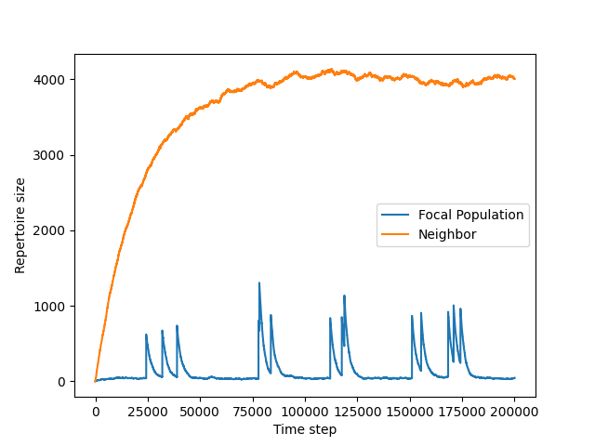

**Figure S2. When migration rates are low enough, cultural repertoire size has enough time to reduce to equilibrium between migration events.** This figure shows, in blue, the cultural repertoire size over time of a population of size 200 connected to a population of size 2000 with a migration rate of 10⁻⁷ per individual (all other parameters were set to default values, as described in Methods). Cultural repertoire size peaks after each migration event, but since they are far enough apart, it returns to its equilibrium value in isolation between migration events. This example demonstrates that when connectivity is low enough, the effective cultural population size of an interconnected population can often be close to the census size, thus maintaining the relationship between population size and cultural complexity.

**Figure S3. The relationship between the rate of connectivity and repertoire size follows a sigmoid-like curve.** We demonstrate that, according to our model, the relationship between connectivity and the cultural repertoire size of a population is expected to be non-linear, and therefore difficult to control for. This figure shows the relationship between the log-transformed cultural repertoire size of a population of size 100 connected to another population of the same size with a migration rate ranging between 10⁻⁶ and 1. The individual probability of invention was 0.01 and the probability of loss was 0.01 per tool at the population level for a population of size 100; see Methods. Our results show that the relationship between connectivity level and cultural repertoire size is expected to be sigmoid-like: when migration is very rare, the repertoire size has enough time to reduce to its equilibrium at isolation (see Figure S2), while when it is very common, the contribution of each additional migrant is reduced, since the tools it carries are very likely to have been introduced by others.